**QUESTION/ANSWER**

#### Ans 1: Organizational structure outlines the essential and important members and departments of the organization. Organizational structure of any organization is also refers the flow and hierarchy of the organization .Organizational structure is also defines how activities , tasks are performed , allocation and deallocation of the resources to the employee , how important decision can take after passing the senior person of the organization. Organizational is also refer the simply the way of pattern and and division of the role and responsibility among employee .In this given diagram we mention the complete hierarchy of any organization, we place the members of the organization based on their ranking. And here also we mention the department of the organization as well. (Bernardin,2006)

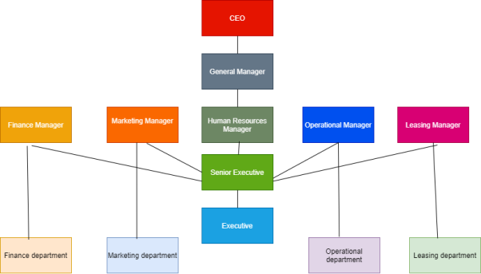

**Ans 2:** Human resource management is a management of an organization that is responsible for managing human resources, work force of employees and resolve their issues. Human resource management is also responsible for allocating, deallocating, rewarding rewards and resources to the employee. Human resource management is also responsible for the selection and rejection of the employee that it conducts the interviews of employees and then decided that whether that employee is applicable to work in this organization or not. Once hired the employee then people of Human resource management give training, understanding of work and other things that is important for that organization. There is a very huge importance, and it is very crucial for any organization because it ensure the right quality of the people, it provides the facilities to the employee and give motivation to evert employee. This is very beneficial for employees’ career because it gives empowerment to the employee.(Noe et al, 2017)

**Ans 3:** There are lots of role and responsibilities of Human resource manager. He directs the employee, making plan for the organization, take essential and important decision, conducting interviews of the employee, appointed the. Employee, making different strategies to enrich the organization resources, making a contract with different organizations and many more means lot softer role of human resource manager .There are also lots of responsibility of human resource manager that he used to developing and implementing hr strategies that must be Aligned with the overall strategy of the organization . Human resource manager also make bridging between the organization and the employee and make a bridging between from one to another organization (Rao, P. and Teegen,2009)

**Ans 4:**  Human resource planning have very strict and hard strategies and it never compromise at any cost . Whether there are shortage of the e employees or there has access amount of work but the main. Motive of human resource planning is just to ensure and give the quality work always (Wright, 2007)

There are basically five steps the Human resource planning always follows and that are given below.

1: Analysed the plans and objectives of the organization.

2: Analysis the objective of Human resource planning and making.

3: keep an eye of human needs and requirements.

4: Make a assessment of supply and demands.

5: overall performance of the organization.

 Analysed the plan and objectives of the organization: In this we used to make a plan for our organization from starting till ending for over all work . After making all necessary plan we used to analyse the panning process and then implement it into an organization.

Analysis the objective of Human resource planning: In this we set the objective of our organization first, whatever we want to achieve in future then set objective and analysed the work.

Keep an eye of human needs:  In this we used to focus firstly whatever plan we make and whatever objective we set but ensure that it fulfil the requirements and needs of human

Make an assessment of supply and chain: In this we used to focus on that whether the supply fulfil the needs of the demands. If it does not fulfil then set according to that.

Overall performance of the organization: In last we used to ensure the performance and working strategies of the organization whether it goes in right direction to not.

**Ans 5**:

**Human Resource Planning:** In this we not only hired the employee but also we use to poilished their skills as well.

**Recruitment:** Attract the employees who are fit for the job

**DE recruitment:** Process through which we reduce workforce.

**Selection:** In this we use to select the employees after conducting the interview of each and every candidates.

**Training and Development :** In this phase we use to train the employee and polish their skills.

**Orientation:** Once we hire the on the first day we set the orientation meeting.

**Performance appraisal:** In this we used to judged the performance of the employees by weekly or by monthly and then we used to give appraisal to the employees.

**Career development:** In this we use to focus on the development of employee career

**Labor satisfaction:** In this we try every possible attempt to satisfy our labor.

**Adapted the skills:** Once we appoint the employee, we accept the basic skills and then update it.

**High performance employee :** In this we can separate the high performance employee.

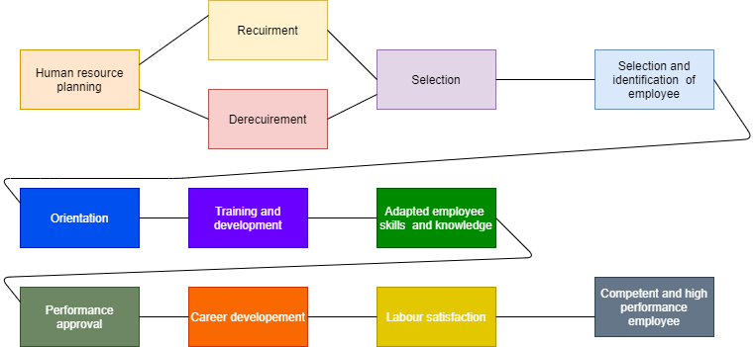

**References**

* Bernardin, H.J. and Russell, J.E., 2006. *Human resource management* (p. 736). Tata McGraw-Hill.
* Noe, R.A., Hollenbeck, J.R., Gerhart, B. and Wright, P.M., 2017. *Human resource management: Gaining a competitive advantage*. New York, NY: McGraw-Hill Education.
* Rao, P. and Teegen, H., 2009. Human resource management.
* Mondy, R.W. and Martocchio, J.J., 2016. *Human resource management*. Pearson.
* Noe, R.A., Hollenbeck, J.R., Gerhart, B.A. and Wright, P.M., 2007. Fundamentals of human resource management.